# Generative AI Tools for Quantitative Research

## Image description for accessibility

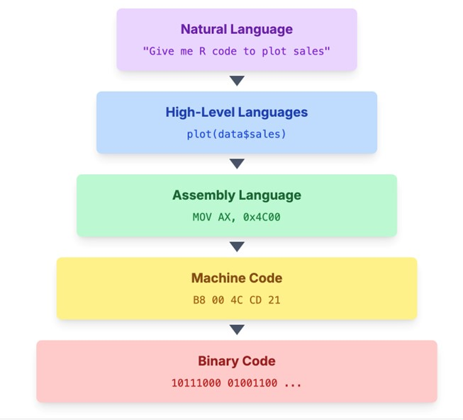

The image illustrates the hierarchy of programming languages and their translations down to binary code. It consists of five horizontal rectangles stacked vertically, each representing a different level of programming language. At the top, a lavender rectangle labelled "Natural Language" contains the text "Give me R code to plot sales." Below it, a light blue rectangle labelled "High-Level Languages" includes the text "plot(data$sales)." The third layer is a light green rectangle labelled "Assembly Language" accompanied by "MOV AX, 0x4C00." The fourth layer features a light yellow rectangle with "Machine Code" and "B8 00 4C CD 21." Finally, at the bottom, a pink rectangle labelled "Binary Code" displays "10111000 01001100 ..." Each rectangle has a downward-pointing arrow indicating the translation from one language to the next.

See full resource: <https://www.ncrm.ac.uk/resources/online/all/?id=20859>

National Centre for Research Methods (NCRM)  
Social Sciences  
Murray Building (Bldg 58)  
University of Southampton  
Southampton SO17 1BJ  
United Kingdom

**Web** www.ncrm.ac.uk   
**Email** info@ncrm.ac.uk  
**Tel** +44 23 8059 4539  
**Twitter** @NCRMUK